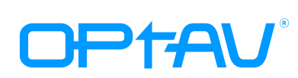 Professional Audio/Visual Over Fiber Solution Manufacturer

4K Single LC Fiber Extender with Pigtail: USB-C to USB-C

OCTOPUS-CC-P01
OCTOPUS-CC-P01 is a full 4k UHD video fiber extender, which resolution is up to 4096*2016@ 60Hz 4:4:4 (DSC2:1). This USB-C fiber extender delivers a maximum bandwidth of 18Gbps. It fully supports DP Alt Mode and is compatible with both single-mode (SMF) and multi-mode (MMF) fibers. The transmission distance is up to 300M over MMF and 20KM over SMF.

The extender pair is using CWDM technology, there are 2 wavelength lasers in the extender pair, 1270nm and 1330nm.

Features
- Support 18Gbps video bandwidth.
- Video resolution up to 3840*2160 50/60HZ(YUV 4:4:4).
- Support DP Alt Mode and compliant with DP 1.2.
- Support LPCM 7.1CH, AES67, DSD, Dolby 5.1, Dolby Atmos, DTS：X Audio.
- EDID management through USB Type-C(female), support EDID pass-through and auto-adaptation. Built-in fixed list of commonly used EDIDs, allowing reading, displaying, and saving the EDID of the display end, and also support direct writing of .bin files.
- Transmission distance up to 300 meters over OM3 Multi-mode fiber, or 20KM over single-mode fiber.
- Low EMI.
- Compact size and detachable structure, easy and flexible for installation.
- Support mixed matching and interconnection with other interfaces (HDMI, DVI, DP) in the same product series.

Optical
- Optical source: CWDM DFB Laser
- Fiber: 1 core LC, Single Mode or Multi Mode
- Distance: MM:300M SM:20KM

Package
- TX x 1
- RX x 1
- 5V/1A power adapter x 2
- USB-A to USB-C cable x2

www.optav-tech.com

+86.137.2421.5827
freya@optav-tech.com

5th floor, High-tech industrial park, NO.1 Dezheng Road,
Shilong Community, Bao'an District, Shenzhen, China
5th floor, High-tech industrial park, NO.1 Dezheng Road,
Shilong Community, Bao'an District, Shenzhen, China

5th floor, High-tech industrial park, NO.1 Dezheng Road,
Shilong Community, Bao'an District, Shenzhen,China

Application

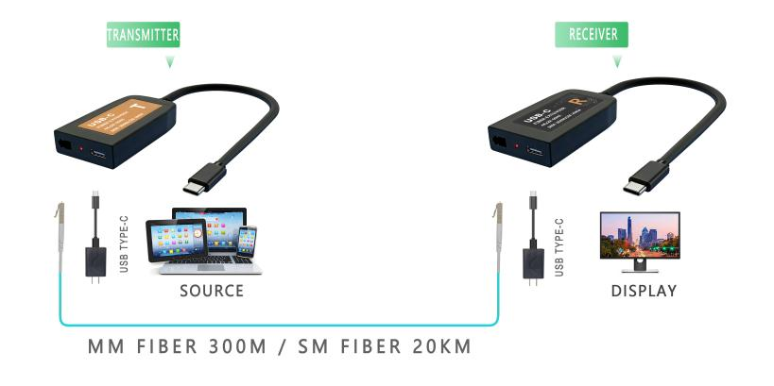

Specification
 | Transmitter | Receiver
Compliance | DP1.2
HDCP | -
Video Bandwidth | 18Gbps
Distance | Single-mode fiber: 20KM  Multi-mode fiber: 300M
Supporting Resolution | 4Kx2K@60HZ(4:4:4 8bit)
Connector/Fiber | USB-C (male)/ LC | LC/USB-C(male)
CWDM filter | Integrated 1270nm/1310nm filter
Power Supply | 5V/1A | 5V/1A
Power Consumption | 3W | 2W
Color | Black | Black
Dimension(LxWxH) | Pigtail: 190MM
Dimension(LxWxH) | Model: 64x35x12.3MM | Model: 64x35x12.3MM
Dimension(LxWxH) | Package:250x180x37MM
Weight | Model: 85 g | Model: 85 g
Weight | Package：450 g
Environment | Operating Temperature Range: -10°C~60°C  Storage Temperature Range: -40°C~85°C
Relative Humidity | 20-90% RH (no condensation)

5th floor, High-tech industrial park, NO.1 Dezheng Road, +86 137 2141 5827
Shilong Community, Bao'an District, Shenzhen,China

5th floor, High-tech industrial park, NO.1 Dezheng Road,
Shilong Community, Bao'an District, Shenzhen, China
+86.137.2421.5827
freya@optav-tech.com
www.optav-tech.com

